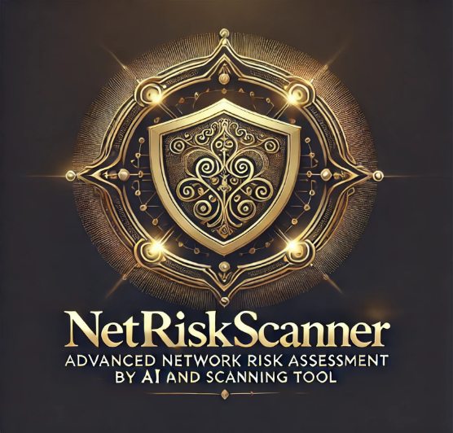

**<< NetRiskScanner >>**

**Advanced Network Risk Assessment by AI and Scanning Tool**

**Authors:**

**Mohammad Majdalawy (2021904045)**

**Mustafa Banikhalaf (2021904052)**

**Supervised By**

**Dr. Malek Barhoush**

**Graduation Project | 2024 -2025**

**FINAL YEAR GRADUATION PROJECT**

**Information Technology Department**

**Faculty of Information Technology and Computer Science**

**Yarmouk University**

**Irbid - Jordan**

**Contact Information**

**This Project report is submitted to the Department of Information Technology/Cyber Security program at Yarmouk University in partial fulfilment of the requirements for the degree of Bachelor of Information Technology in Cyber security.**

**Authors:**

1. **Mohamad Majdalawy (2021904045)**

**Address: Irbid, Jordan**

**E-mail:** [**2021904045@ses.yu.edu.jo**](mailto:2021904045@ses.yu.edu.jo)

1. **Mustafa Banikhalaf (2021904052)**

**Address: Irbid, Jordan**

**E-mail:** [**2021904052@ses.yu.edu.jo**](mailto:2021904052@ses.yu.edu.jo)

**2025 – January**

**Supervisor:**

**Dr. Malek Barhoush**

**Business Information Technology**

**Department of Information Technology**

**Internet: http://yu.edu.jo**

**Faculty of Information Technology and Computer Sciences**

**Phone: +962 2 72711111 Ext. 2561**

**Yarmouk University, Jordan**

**Fax: +962 2 7211111**

**Graduation Project Report**

**Department of Information Technology**

**Faculty of Information Technology and Computer Sciences**

**Yarmouk University – Jordan**

**Intellectual Property Right Declaration**

**This is to declare that the work, under the supervision of Dr. Malek Barhoush, titled “NetRiskScanner: Advanced Network Risk Assessment and Scanning Tool” carried out in partial fulfillment of the requirements for the degree of Bachelor of Cybersecurity, is the sole property of Yarmouk University and the respective supervisor. It is protected under intellectual property laws and conventions. Any use of this work, including extension, enhancement, or commercial application, must have prior permission from the University and the respective supervisor.**

**Date: 9/1/2025**

**Author(s):  
 Name: Mohamad Majdalawy**

**Signature: _____________________  
 Name: Mustafa Banikhalaf**

**Signature: _____________________**

**Supervisor(s):  
Name: Dr. Malek Barhoush**

**Signature: _____________________**

**Anti-Plagiarism Declaration:**

**This is to declare that the above publication produced under the supervision of Dr. Malek Barhoush having title “NetRiskScanner: Advanced Network Risk Assessment and Scanning Tool” is the sole contribution of the author(s) and no part hereof has been reproduced illegally (cut and paste) which can be considered as Plagiarism. All referenced parts have been used to argue the idea and have been cited properly. I/We will be responsible and liable for any consequence if violation of this declaration is proven.**

**Date: 9/1/2025**

**Author(s):**

**Name: Mohamad Majdalawy**

**Signature: ____________**

**Name: Mustafa Banikhalaf**

**Signature: ____________**

**ACKNOWLEDGMENTS**

**We express our deepest gratitude to our supervisor, Dr. Malek Barhoush, for their invaluable guidance and support throughout this project. Special thanks to our families and friends for their unwavering encouragement and belief in us.**

**Abstract:**

**NetRiskScanner simplifies network security auditing by integrating a graphical interface with Nmap’s powerful command-line scanning capabilities. It allows users to perform various network scans, including port detection, OS identification, service enumeration, and network risk assessment, with user-friendly controls and real-time feedback. The tool incorporates threading for efficient execution, robust validation to minimize errors, and output exporting to enhance usability. This project demonstrates a practical application of cybersecurity principles and addresses the complexities of network scanning through an accessible and effective interface. The inclusion of advanced features like risk analysis makes it a comprehensive tool for network security evaluation.**

**Screen about tool interface**

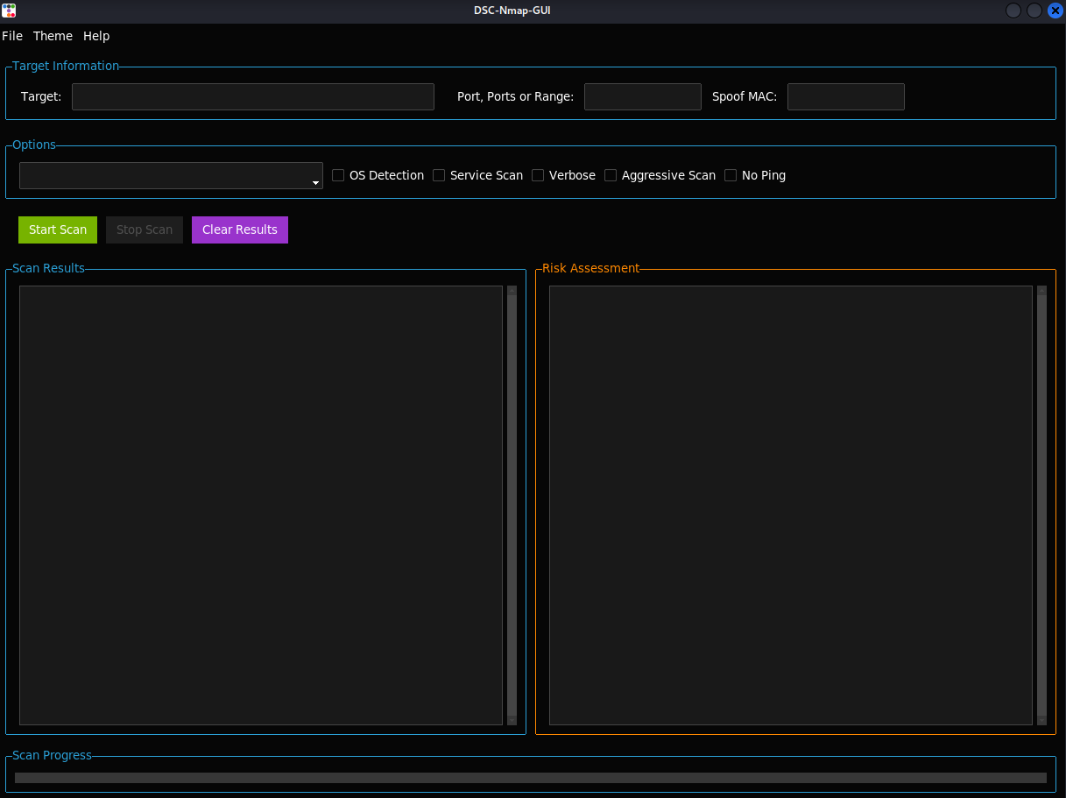

**Table of Contents:**

1. **Introduction.**

**2. Purpose of the Project.**

**3. Scope of the Project.**

**4. Benefits of the Project.**

**5. System Analysis.**

**-Existing Systems.**

**-Problems in Existing Systems.**

**6. Proposed Solutions.**

**7. System Design.**

**-System Architecture.**

**8. Component Descriptions.**

**9.Implementation and Validation.**

**-Key Functionalities.**

**-Validation and Testing.**

**10.Conclusion and Future Enhancements.**

**11. References.**

**1.Introduction:**

**NetRiskScanner**

**Advanced Network Risk Assessment by AI and Scanning Tool**

**project is an initiative aimed at leveraging the capabilities of Nmap, a powerful open-source network scanning tool, to enhance network security and performance analysis. This project builds upon the foundational functionalities of Nmap to provide additional features, streamlined workflows, or customized functionalities tailored to specific use cases in network management and cybersecurity.**

**What is Nmap?**

**Nmap (Network Mapper) is a widely used tool in the field of cybersecurity and network administration. It allows users to perform tasks such as:**

* **Network Discovery: Identifying devices and hosts on a network.**
* **Port Scanning: Detecting open ports and associated services on networked devices.**
* **Vulnerability Assessment: Analyzing system vulnerabilities by identifying weak points in the network.**
* **Service Detection: Determining running services and their versions.**

**Screen about Tool Services**

**2. Purpose of the Project:**

**The purpose of NetRiskScanner is to provide a user-friendly interface for conducting advanced network scans using Nmap. By abstracting the complexities of command-line operations, this tool allows cybersecurity professionals and students to easily analyze networks, identify vulnerabilities, assess risks by AI, and ensure system security.**

**3. Scope of the Project:**

**The project focuses on integrating essential Nmap functionalities, including target validation, various scan types, real-time progress updates, and risk assessment features into a graphical user interface (GUI). The tool targets individuals with limited command-line experience while maintaining robust scanning capabilities for advanced users.**

**4. Benefits of the Project:**

* **Simplifies the process of network scanning and risk assessment through an intuitive GUI.**
* **Provides real-time feedback on scan progress and results.**
* **Ensures efficient and accurate scans with built-in validation mechanisms.**
* **Facilitates result export for reporting and documentation purposes.**
* **Introduces advanced features for identifying and evaluating network vulnerabilities and risks.**

**5.System Analysis:**

* **Existing Systems:**

**Existing network scanning tools like Nmap rely heavily on command-line interfaces, which can be intimidating for inexperienced users. Moreover, these systems often lack interactive feedback and require extensive knowledge of command syntax. Risk assessment features are also typically separate from scanning tools, making comprehensive evaluation cumbersome.**

* **Problems in Existing Systems:**
  + **Steep learning curve for non-technical users.**
  + **Limited accessibility for those unfamiliar with command-line tools.**
  + **Difficulty in managing large-scale scans without progress tracking or export options.**
  + **Absence of integrated risk assessment features.**

**6. Proposed Solutions :**

* **NetRiskScanner addresses these issues by providing:**
* **An intuitive graphical interface.**
* **Robust input validation to minimize errors.**



* **Real-time progress updates and detailed results.**
* **Risk analysis integrated with scan results.**

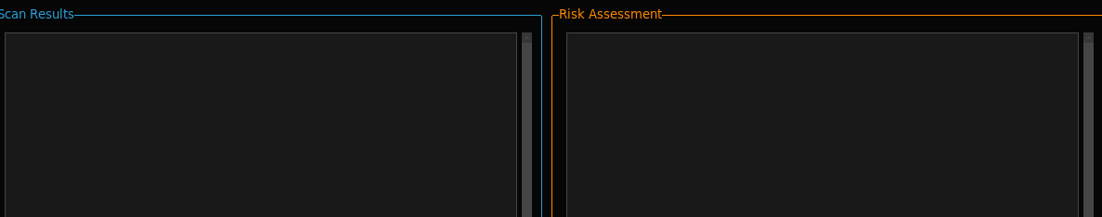

* **Functionality to export scan outputs for further analysis.**

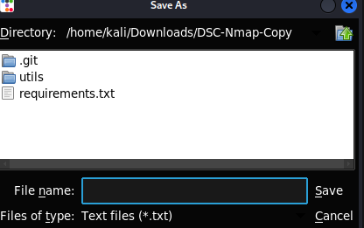

**7.System Design :**

1. **System Architecture:**

* **The architecture integrates the following modules:**
* **GUI Module: Manages user input and displays outputs.**
* **Scan Execution Module: Manages threading and Nmap command execution.**
* **Validation Module: Ensures correct input formats for targets and ports.**
* **Result Parsing Module: Processes Nmap outputs and displays them in a structured format.**
* **Risk Assessment Module: Analyzes scan results to provide insights on potential vulnerabilities and threats.**

**8.Component Descriptions:**

* **Input Fields: Collect target IP/domain and port range.**



* **Dropdowns and Checkboxes: Allow users to select scan types and additional options like OS detection.**

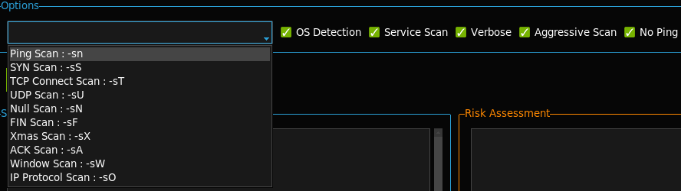

* **Risk Assessment: Provides detailed insights into potential vulnerabilities based on scan results.**
* **Export Functionality: Save results to text files for future reference.**
* **Result Display: Show real-time scan progress and outputs.**

**9.Implementation and Validation:**

* **Key Functionalities:**
* **Target Validation: Ensures valid IPs, domains, and port ranges.**
* **Scan Options: Supports multiple scan types, including TCP, UDP, OS detection, and risk analysis.**
* **Real-Time Updates: Displays progress and results dynamically.**
* **Threading: Ensures responsive GUI during scan execution.**
* **Risk Assessment: Identifies potential vulnerabilities and prioritizes risks for mitigation.**
* **Result Export: Allows users to save scan outputs for reporting.**
* **Validation and Testing:**
* **Functional Testing: Verified all input fields, scan options, and result displays.**
* **Stress Testing: Conducted scans on large networks to ensure stability.**
* **Usability Testing: Gathered feedback from peers to refine the interface and features.**
* **Risk Validation: Evaluated the accuracy of risk assessment by comparing outputs with known vulnerabilities.**

**10.Conclusion and Future Enhancements:**

**Conclusion:**

**NetRiskScanner successfully bridges the gap between powerful network scanning capabilities and ease of use. By abstracting complex commands into a simple interface and incorporating risk analysis, the tool empowers users to conduct comprehensive network audits efficiently and identify vulnerabilities effectively.**

**Future Enhancements:**

* **Add advanced visualization of scan results.**
* **Incorporate support for additional Nmap features like scripting and firewall evasion.**
* **Expand compatibility for cross-platform use.**
* **Integrate machine learning algorithms to enhance risk prediction and vulnerability analysis.**

**11. References:**

* **Nmap Documentation: https://nmap.org/docs.html**
* **Python Tkinter Library: https://docs.python.org/3/library/tkinter.html**
* **Threading in Python:** [**https://docs.python.org/3/library/threading.html**](https://docs.python.org/3/library/threading.html)
* **To install tool: https://github.com/MustafaFBK/DSC-Nmap-Copy.git**